**Energy Consumption by State Methodology**

**&**

**Energy Deficit Methodology**

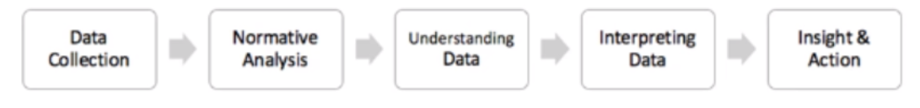

1. **DATA COLLECTION**

|  |  |
| --- | --- |
| Data Source | **Details** |
| <http://censusindia.gov.in/2011-prov-results/prov_rep_tables.html> | Population of states (2011)  (table1) |
| <https://data.gov.in/node/6568241> | electronification rate (2017) |
| <https://www.statista.com/statistics/271312/urbanization-in-india/> | Rate of growth of Urban population (2017) |

1. **Population of states (rural vs. village):**
   1. **Assumption**: 1.3% YoY Growth
   2. With annual growth pf 1.3% Year over year, the population is calculated from 2012-2021
   3. Assumption validated by cross checking with Decadal growth rate of each state and converting into annual rate

* current value (1+Annual rate) ^10=current value(1+decadalRate)

1. **Consumption by Region (electrification rate)**
   1. **Assumption**: while calculating electrification rate, Urban population has been accounted with 34% which is supported by statistics of 2017 and the electrification of urban area is 100%.
   2. The Electrification rate for each state has been calculated as

* Total # of households/ (Total # of households electrified in urban and rural)
  1. The state wise data has been summarized to region wise.

1. **Consumption per Capita by State**
   1. **Assumption**: Transmission cost as 10%

Electronification Factor Growth 3% YoY

* Consumption per capita = total consumption/ total population
  1. As India is not fully electrified, total population cannot contribute to per capita, so the electrification rate is brought into account to nullify the effect
* Consumption per capita = total consumption / (total population * Electronification rate)
  1. **Consumption by state(2016)**: The data of consumption is available region wise, which can be disaggregated to state wise (2016) with the available % deficit by state (2016) and Installed capacity to generate (2016)
* Installed capacity to generate = Deficit * Consumption * 1.1 (10% Transmission Cost)
  1. **Electronification factor**: The electronification factor is calculated for 2016 from 2017 year. (3% Y-o-Y growth)
  2. Consumption per Capita by State is calculated for 2016
* Consumption by state (2016) / (Population of state (2016) * Electronification factor (2016)

1. **Aggregate to State Level**
   1. States are aggregated Region wise
   2. Summarizing the Installed capacity to generation (2016) and calculated consumption by state (2016) to region wise.
   3. Electronification factor is considered region wise
   4. Consumption per capita region wise for 2016 is calculated
      * Consumption by region (2016) / (Population of region (2016) *Electronification factor (2016)
2. **Forecasted India (2014-2040)**
   1. Using forecasted Population and energy consumption, consumption per capita and electronification factor can be forecasted till 2040 using Tableau.